**Cooking Utensils List That Every Kitchen Needs**

1. A **baster** is handy for returning some of the meat or poultry juices from the pan, back to the food. Basting brushes can be used for the same purpose, but they are also convenient for buttering the tops of breads and baked goods after they come out of the oven.

2. **Cans, bottles, cartoons opener** use to open a food tin, preferably with a smooth operation, and comfortable grip and turning knob.

3. **Colanders** also called a vegetable strainer are essential for various tasks from cleaning vegetables to straining pasta or tin contents.

4. **Cutting Boards** a wooden or plastic board where meats and vegetables can be cut.

5. **Dredgers** – used to shake flour, salt, and pepper on meat, poultry, and fish.

6. **Double boiler** – used when temperatures must be kept below boiling, such as for egg sauces, puddings, and to keep foods warm without overcooking.

7. **Emery boards/sharpening steel** – used to sharpen long knives.

8. **Flipper** use for turning hamburgers and other food items

9. **Funnels** – used to fill jars, made of various sizes of stainless steel, aluminum, or of plastic

10. **Garlic Press** is a kitchen tool which is specifically designed for the purpose of pulping garlic for cooking.

11. **Graters** used to grate, shred, slice and separate foods such as carrots, cabbage and cheese.

12. **Handy Poultry & Roasting Tools** make it easier to lift a hot roasted turkey from the roaster to the serving platter, without it falling apart.

13. **Kitchen Knives** often referred to as cook's or chef's tools, knives are a must for all types of kitchen tasks, from peeling an onion and slicing carrots, to carving a roast or turkey

14. **Kitchen Shears** They are practical for opening food packages, cutting tape or string to package foods or simply to remove labels or tags from items. Other cutting tools such as box cutters are just as handy, especially for opening packages.

15. **Measuring Cups, Spoons Measuring tools** are among the most important items found in any kitchen, since consistently good cooking depends upon accurate measurements. Measuring tools should be standardized. Measuring cups and spoons are also in the home kitchen. Scales are used to weigh materials of bigger volumes. These are delicate and precision instruments that must be handled carefully and are more dependable in terms of accuracy.

16. **Pasta Spoon or Server** is use to transfer a little or much cooked pasta to a waiting plate, without mess. Pasta spoons are best used with spaghetti-style or other long pasta noodles; you can use a large slotted serving spoon for short pastas.

17. **Potato Masher** used for mashing cooked potatoes, turnips, carrots or other soft cooked vegetables.

18. **Rotary eggbeater** – used for beating small amount of eggs or batter. The beaters should be made up of stainless steel, and gear driven for ease in rotating

19. **Scraper**- a rubber or silicone tools to blend or scrape the food from the bowl; metal, silicone or plastic egg turners or flippers

20. **Seafood Serving Tools** make the task of cleaning seafood and removing the shell much easier. For cooking seafood, utensils will vary depending on what you are cooking.

21. **Serving** **spoons**- a utensil consisting of a small, shallow bowl on a handle, used in preparing, serving, or eating food.

22. **Serving Tongs** enables you to more easily grab and transfer larger food items, poultry or meat portions to a serving platter, to a hot skillet or deep fryer, or to a plate. It gives you a better grip and the longer the tongs, the better especially when used with a deep fryer, a large stock pot or at the barbecue.

23. **Soup Ladle** is used for serving soup or stews, but can also be used for gravy, dessert sauces or other foods. A soup ladle also works well to remove or skim off fat from soups and stews.

24. **Spoons** – solid, slotted, or perforated. Made of stainless steel or plastic, the solid ones are used to spoon liquids over foods and to lift foods, including the liquid out of the pot

25. **Temperature Scales** - used to measure heat intensity. Different thermometers are used for different purposes in food preparation – for meat, candy or deep-fat frying. Other small thermometers are hanged or stand in ovens or refrigerators to check the accuracy of the equipment’s thermostat.

26. **Two-tine fork** – used to hold meats while slicing, and to turn solid pieces of meat while browning or cooking Made of stainless steel and with heat-proof handle. 27. Vegetable peeler. used to scrape vegetables, such as carrots and potatoes and to peel fruits. The best ones are made of stainless steel with sharp double blade that swivels.

28. **Whisks for Blending, Mixing** used for whipping eggs or batter, and for blending gravies, sauces, and soups. The beaters are made of looped steel piano wires which are twisted together to form the handle

29. **Wooden spoons** continue to be kitchen essentials because of their usefulness for used for creaming, stirring, and mixing. They should be made of hard wood.

**Equipment**

More complicated tools are called equipment. They may refer to a small electrical appliance, such as a mixer, or a large, expensive, power-operated appliance such a range or a refrigerator.

Equipment like range, ovens, refrigerators (conventional, convection and microwave) are mandatory pieces in the kitchen or in any food establishment.

1. **Refrigerators/Freezers** are necessary in preventing bacterial infections from foods. Most refrigerators have special compartment for meat, fruits and vegetables to keep the moisture content of each type of food. Butter compartment holds butter separately to prevent food odors from spoiling its flavor. Basically, refrigerator or freezer is an insulated box, equipped with refrigeration unit and a control to maintain the proper inside temperature for food storage.
2. **Auxiliary equipment like griddles, tilting skillets, broilers/grills, steamers, coffee makers, deep-fat fryers, wok, crockery, cutting equipment (meat slicer, food choppers, grinders) mixers and bowls, pots and pans** are utilized most commonly in big food establishments, some with specialized uses and some are optional.
3. **Microwave Ovens** have greatly increased their use in the food industry. Foods can be prepared ahead of time, frozen or refrigerated during the slack periods, and cooked or heated quickly in microwave ovens
4. **Blenders** are used to chop, blend, mix, whip, puree, grate, and liquefy all kinds of food. A blender is a very useful appliance. They vary in the amount of power (voltage/wattage). Others vary and do not do the same jobs.

Name: Date:

Grade: Score:

**Test I. Identify the following kitchen utensils.**

1. Used to grate, shred, slice and separate foods such as carrots, cabbage and cheese.
2. Also called a vegetable strainer are essential for various tasks from cleaning vegetables to straining pasta or tin contents.
3. Is handy for returning some of the meat or poultry juices from the pan, back to the food. Basting brushes can be used for the same purpose, but they are also convenient for buttering the tops of breads and baked goods after they come out of the oven.
4. Enables you to more easily grab and transfer larger food items, poultry or meat portions to a serving platter, to a hot skillet or deep fryer, or to a plate.
5. They are practical for opening food packages, cutting tape or string to package foods or simply to remove labels or tags from items.
6. A wooden or plastic board where meats and vegetables can be cut.
7. Used to measure heat intensity. Different thermometers are used for different purposes in food preparation – for meat, candy or deep-fat frying. Other small thermometers are hanged or stand in ovens or refrigerators to check the accuracy of the equipment’s thermostat.
8. A rubber or silicone tools to blend or scrape the food from the bowl; metal, silicone or plastic egg turners or flippers
9. Used for mashing cooked potatoes, turnips, carrots or other soft cooked vegetables.
10. Make the task of cleaning seafood and removing the shell much easier.

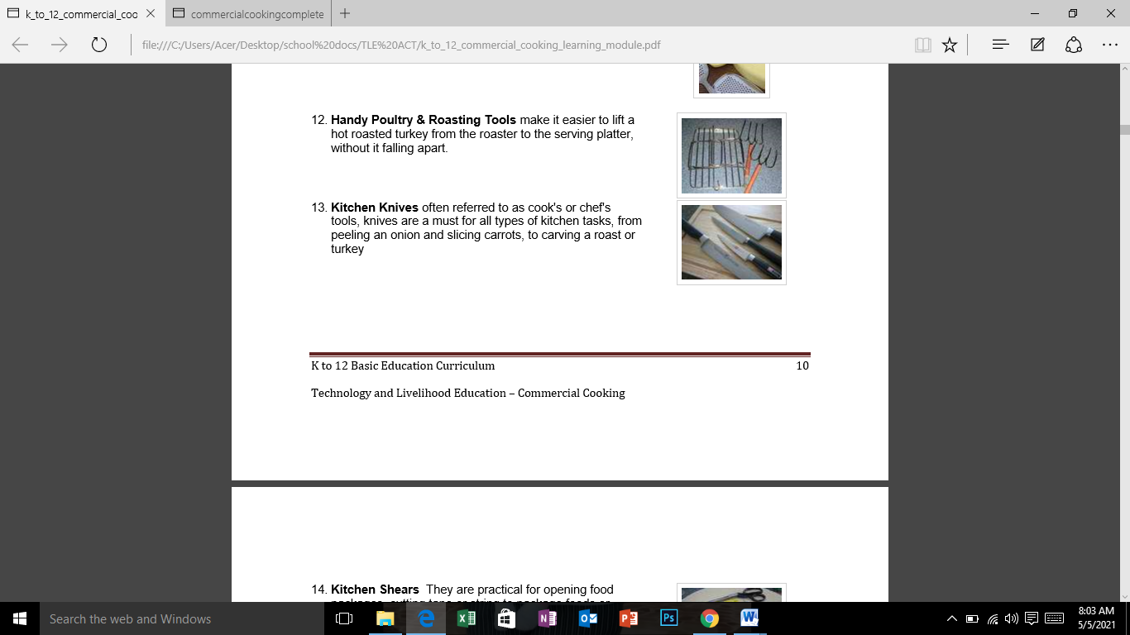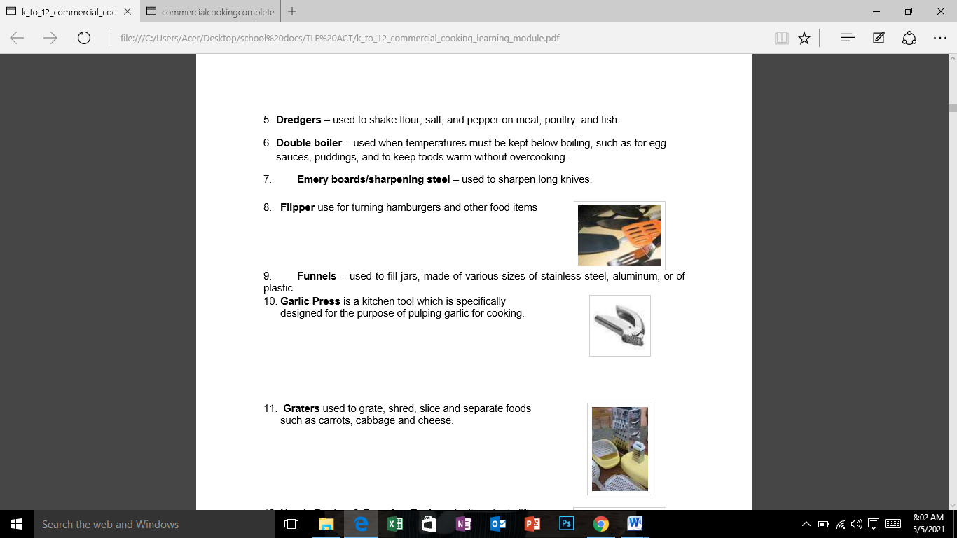**Test II. Guess Me!**

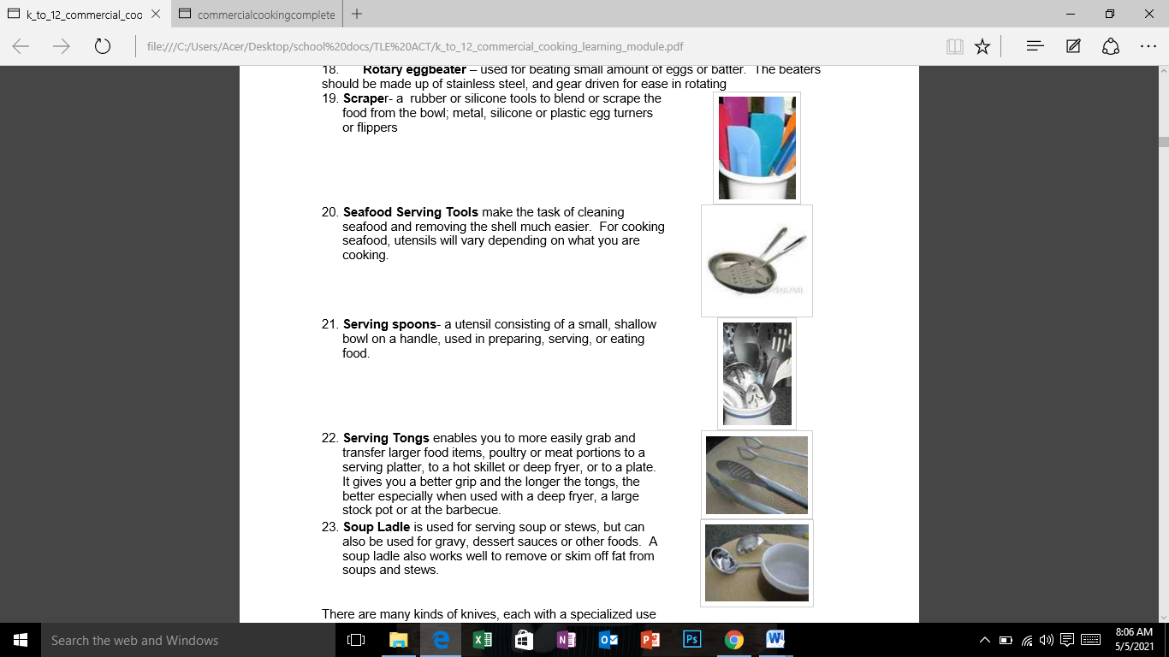

**Performance Task No. 1**

**Demonstrate the proper use of kitchen utensils.**

|  |  |
| --- | --- |
| SCORING RUBRIC | |
|  | Score/Rate |
| Demonstrated and identified 15 kitchen utensils | 100 |
| Demonstrated and identified 14 kitchen utensils | 95 |
| Demonstrated and identified 13 kitchen utensils | 90 |
| Demonstrated and identified 12 kitchen utensils | 85 |
| Demonstrated and identified 11 and below kitchen utensils | 80 |



Attendance 5/5/21

James, Princess, Criztel, Joana, Princess

Robin Izeah Siomeon